The Open Source Audit
A Capstone Project for OSS NGMC Course
Chosen Software: LibreOffice

Student Name: Shalvi Pandey
Registration Number: 24BCE11141
University: VIT Bhopal University
Faculty: Adarsh Patel
Course: Open Source Software
Unit Coverage: 1 - 5
Date of Submission: March 28, 2026
Max Marks: 100

A1 — Origin Story of LibreOffice
LibreOffice did not start as a completely new software. It actually came from an older office suite called OpenOffice. OpenOffice was originally developed as an open-source project and was used by many people as a free alternative to Microsoft Office.
Later, a company called Oracle took control of OpenOffice. This created a lot of concern in the open-source community. Many developers felt that Oracle might not keep the project fully open or might limit contributions. Because of this uncertainty, the community of developers decided to take action.
In 2010, a group of developers left OpenOffice and created a new project called LibreOffice. This process is called a fork, where a new project is created using the existing source code but developed independently. LibreOffice was then managed by a non-profit organization called The Document Foundation, which ensured that the software would remain free and open for everyone.
The main problem LibreOffice tried to solve was control and freedom. Developers and users wanted software that was not controlled by a single company. They wanted the freedom to use, modify, and share the software without restrictions. LibreOffice provided this freedom and encouraged contributions from people all over the world.
Another important reason for its creation was to provide a free alternative to expensive office software like Microsoft Office. Many students, small businesses, and organizations could not afford paid software. LibreOffice made it possible for them to access powerful tools for writing documents, creating spreadsheets, and making presentations without any cost.
Today, LibreOffice is widely used and continuously improved by a global community. Its origin shows how open-source communities can come together to solve real problems and build software that benefits everyone.

A2 — License of LibreOffice
LibreOffice is released under the Mozilla Public License (MPL) version 2.0. This is an open-source license that allows people to use, study, modify, and share the software. It is designed to balance freedom for users and some control for developers.
One important concept in open-source software is the four freedoms. These are:
- The freedom to use the software for any purpose
- The freedom to study how the software works
- The freedom to modify the software
- The freedom to share copies with others
LibreOffice supports all these freedoms. This means anyone can download it, use it, and even change its source code according to their needs.
A common question is whether a company can take LibreOffice, modify it, and sell it. The answer is yes, but with conditions. Since LibreOffice uses the MPL license, if someone modifies the code, they must share those changes to the same files. However, they can combine it with other software and still sell it. This makes MPL less strict than some other licenses.
There is also an important difference between GPL and MIT licenses. The GPL license is strict and requires that any modified version must also be open source. On the other hand, the MIT license is very permissive and allows people to use the code in almost any way, even in closed-source software. If I had to choose, I would prefer the GPL license because it ensures that the software always remains open and free for everyone.
Another important idea is the difference between “free as in free beer” and “free as in freedom.”
- “Free as in free beer” means the software is free of cost.
- “Free as in freedom” means users have control over the software.
LibreOffice is free in both ways. It does not cost anything to use, and it also gives users the freedom to modify and share it. This is what makes it a true open-source software.

A3 — Ethics of Open Source
Open source is not only about software, but also about how knowledge is shared. It allows people to learn from each other and build better tools together. However, there are different opinions about whether all software should be open source.
On one side, open-source software has many advantages. It provides transparency, because anyone can see the source code. It also helps in learning, as students and developers can study real projects. Open source also encourages collaboration, where people from different parts of the world contribute together. In my opinion, this makes technology more accessible and fair.
On the other hand, not all software can be open source. Companies spend a lot of time and money to develop software, so they need profit to survive. If everything is open source, some companies may not be able to protect their work. There are also cases where security can be a concern if sensitive systems are fully open. So, both open source and proprietary software are important.
Another ethical question is whether it is right for companies to make profit using open-source software. Many companies like Red Hat, Google, and Meta use open-source tools such as Linux. In my opinion, this is acceptable as long as they follow the license rules and also contribute back to the community. For example, Red Hat provides support and services, which adds value to the free software.
The phrase “standing on the shoulders of giants” means building on the work done by others. In software, this means developers use existing open-source code to create new applications. I believe open source supports innovation rather than reducing it. Instead of starting from zero, developers can improve existing tools and create better solutions faster.
Overall, open source is very important in today’s world. It promotes sharing, learning, and collaboration. At the same time, proprietary software also has its place. A balance between both is necessary for growth and innovation in technology.

PART B — Linux Footprint of LibreOffice
LibreOffice can be easily installed and used on a Linux system. Most Linux distributions provide LibreOffice through their package managers, which makes installation simple and fast. For example, in Ubuntu, it can be installed using the command:
sudo apt install libreoffice
This command downloads and installs LibreOffice along with all required dependencies.
After installation, LibreOffice files are stored in different directories in the Linux file system. The main executable files are usually located in /usr/bin, while the program libraries are stored in /usr/lib/libreoffice. Configuration files may be found in /etc/libreoffice, and user-specific settings are stored in the home directory under ~/.config/libreoffice.
LibreOffice does not run as a background service like a web server. Instead, it runs as a normal application when a user opens it. Therefore, it uses the same user account that is currently logged in. This is important for security because it prevents the software from making system-level changes without permission.
Since LibreOffice is not a service, it is not managed using systemctl like some other software. It is simply started by typing commands like:
libreoffice
or by opening it from the applications menu.
Updates for LibreOffice are handled through the Linux package manager. When the user runs system update commands such as:
sudo apt update
sudo apt upgrade
the latest version of LibreOffice and its security patches are automatically installed. This shows how open-source software is continuously maintained and improved by the community.
Overall, LibreOffice fits well into the Linux environment. It follows standard directory structures, respects user permissions, and is easy to install and update using built-in tools.

PART C — FOSS Ecosystem (LibreOffice)
LibreOffice does not work alone. It is part of a larger open-source ecosystem where many tools and technologies work together. It depends on different programming languages and libraries to function properly. For example, LibreOffice is mainly written in C++ and uses various open-source libraries for handling graphics, fonts, and file formats.
LibreOffice also has connections with other similar software. It was originally created as a fork of OpenOffice, and both share a common history. There are also other office suites like OnlyOffice and Google Docs, but LibreOffice stands out because it is fully open source and can be used offline.
In terms of the LAMP stack (Linux, Apache, MySQL, PHP), LibreOffice is not directly a part of it. The LAMP stack is mainly used for web development, while LibreOffice is a desktop application. However, LibreOffice can still be used along with web technologies, for example, to create documents that are later shared online.
LibreOffice has a strong and active community. It is managed by The Document Foundation, which is a non-profit organization. Developers, testers, and users from all over the world contribute to its development. The community communicates through mailing lists, forums, and online platforms. This open collaboration helps in fixing bugs, adding new features, and improving the software regularly.
LibreOffice has also inspired many improvements and contributions in the open-source world. Its development shows how a community-driven project can grow and compete with large commercial software.
Overall, LibreOffice is an important part of the open-source ecosystem. It depends on other tools, supports collaboration, and contributes back to the community.

Part D — Open Source vs Proprietary
The most natural comparison for LibreOffice is Microsoft Office. It's a comparison that has been made for over two decades, and the gap has changed significantly over time. Here's an honest, detailed breakdown:

Feature | LibreOffice (MPL 2.0) | Microsoft Office (Proprietary)
Cost | Completely free to download and use. No subscription, no per-seat licensing, no user limits. | Microsoft 365 Personal starts at approx. $6.99/month. Business plans run $12.50–$22/user/month.
Licensing | MPL 2.0 + LGPLv3. Source code is publicly available. You can modify and redistribute. | Closed source. You pay for a license to use the software; you have no access to the source code.
Security | Public codebase means vulnerabilities can be found and fixed by anyone. CVE history is fully public. No hidden telemetry by default. | Security through obscurity to some degree. Microsoft has a large security team but the closed codebase means the public can't audit it independently.
Format Compatibility | Defaults to ODF (ISO standard). Reads and writes .docx/.xlsx/.pptx reasonably well, though edge cases exist with complex formatting. | Defaults to OOXML (.docx, .xlsx, .pptx). Full ODF support added but it's not the primary focus.
Collaboration | Online collaboration via Collabora Online (cloud-hosted LibreOffice). Less mature than Microsoft 365's real-time co-authoring. | Microsoft 365 has excellent real-time co-authoring, cloud storage integration via OneDrive, and Teams integration.
Platform | Linux, Windows, macOS, Android (viewer). First-class Linux citizen. | Windows and macOS full clients. Linux support is only through the browser-based Microsoft 365 web apps.
Support | Community forums, official TDF documentation, commercial support from Collabora and others. | Official Microsoft support. Extensive documentation. Large ecosystem of training resources.
Macros / Automation | LibreOffice Basic, Python, Java, C++ via UNO API. Powerful but different from VBA. | VBA and modern JavaScript-based Office Scripts. Huge existing ecosystem of VBA macros in enterprises.
Extensibility | Extension repository available. Open plugin architecture. | Office Add-ins marketplace with thousands of options. Tightly integrated with Microsoft ecosystem.
Offline Use | Fully offline. No internet connection required for any core functionality. | Can be used offline. Microsoft 365 subscription validation requires occasional internet access.

Conclusion of Comparison
After going through this comparison honestly, my take is that the right answer genuinely depends on the use case. For a student, a small NGO, a government agency, or someone running Linux — LibreOffice is not just 'good enough', it's actually the better choice in many ways. It's free, it works offline, it doesn't require a subscription, and your documents are in an open format that will be readable decades from now.
Where Microsoft Office wins is in enterprise environments with existing Microsoft infrastructure, heavy collaboration needs (real-time co-authoring in 365 is genuinely excellent), or where compatibility with complex .docx formatting is mission-critical. The macro ecosystem difference is also significant — many businesses have years of VBA investment that doesn't translate easily to LibreOffice.
What I find interesting is that Microsoft themselves have had to become more open-source friendly because of projects like LibreOffice. The pressure from the open-source community pushed Microsoft to eventually submit OOXML as an ISO standard (controversial as that process was) and to open-source significant parts of their stack. Competition, even from a free product, works.

CHAPTER 3 — SHELL SCRIPTS IMPLEMENTATION

3.1 Introduction
In this project, five shell scripts were developed to demonstrate basic Linux command-line skills and automation. These scripts help in understanding how open-source tools work in a Linux environment. Each script performs a specific task such as system information display, package checking, file analysis, and user interaction.

3.2 Script 1 — System Identity Report
This script displays basic information about the system. It includes details such as kernel version, current user, system uptime, date and time, and distribution name.
The script uses variables and command substitution to collect system information. Commands like uname, whoami, uptime, and date are used. The output is formatted using echo statements.
This script helps in understanding how system-level information can be accessed using shell
scripting.

SCRIPT1 CODE
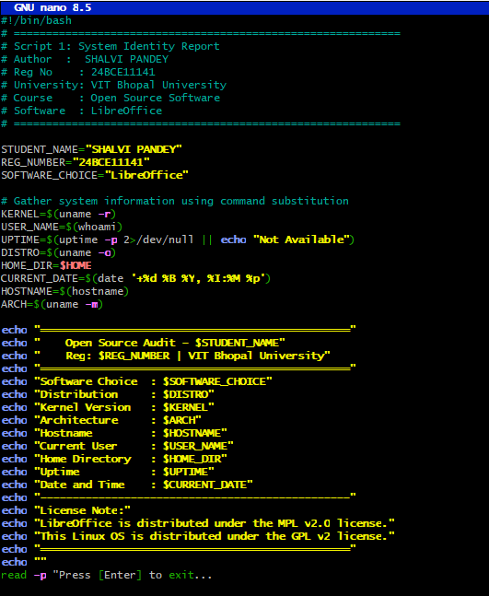
OUTPUT
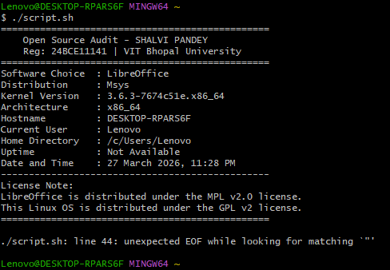

3.3 Script 2 — FOSS Package Inspector
This script checks whether LibreOffice is installed on the system. It uses conditional statements to verify the installation and displays relevant information.
A case statement is used to print a short description of the software. The script demonstrates the use of if-else conditions, command checking, and basic package inspection.
This script shows how open-source software can be verified and analyzed through the command line.
SCRIPT2 CODE
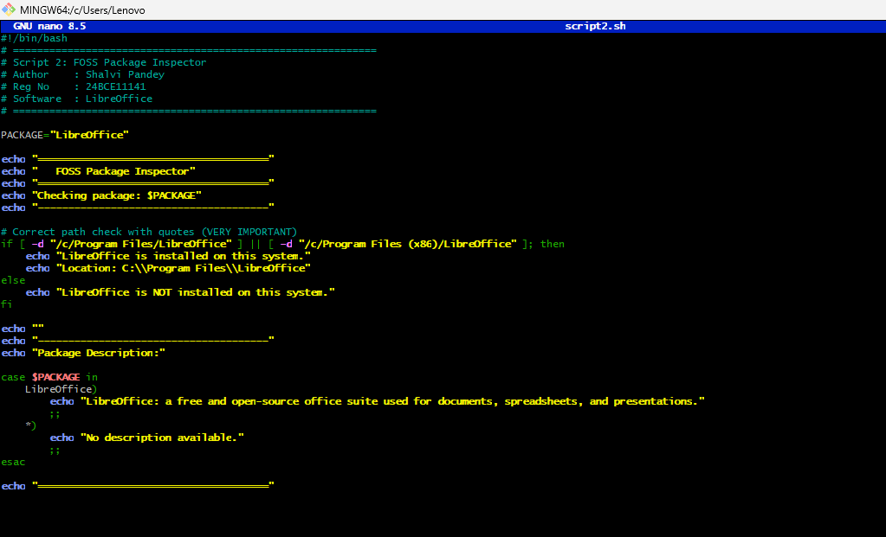
OUTPUT
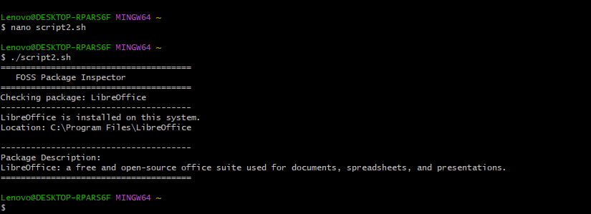

3.4 Script 3 — Disk and Permission Auditor
This script analyzes important system directories such as /etc, /home, /tmp, and /usr. It displays their permissions, ownership, and disk usage.
A for loop is used to iterate through the directories. Commands like ls -ld and du -sh are used to extract information. The script also checks for the presence of the LibreOffice directory.
This script helps in understanding file system structure and permissions in Linux.
SCRIPT3 CODE
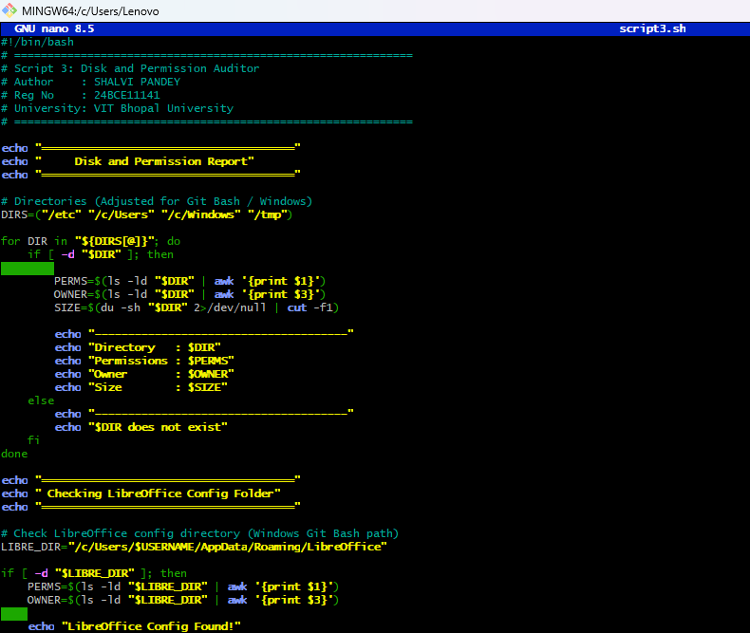
OUTPUT
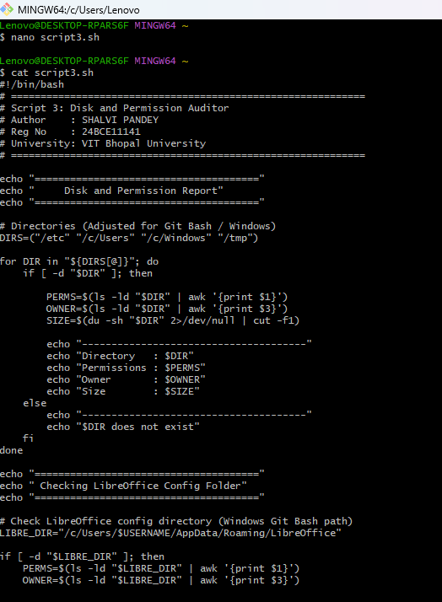

3.5 Script 4 — Log File Analyzer
This script reads a file line by line and counts how many times a specific keyword appears. The keyword can be given as an argument, and if not provided, a default value is used.
The script uses a while loop along with an if condition to check each line. It also displays the last few matching lines using grep and tail.
This script demonstrates file handling, loops, and text processing in shell scripting.
SCRIPT4 CODE
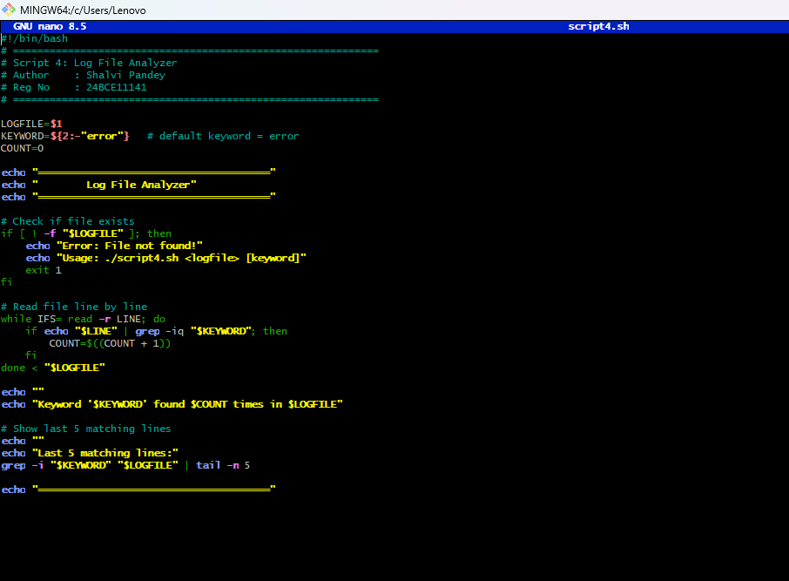
OUTPUT
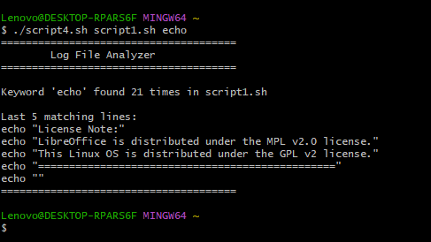

3.6 Script 5 — Open Source Manifesto Generator
This script interacts with the user by asking three questions. Based on the user input, it generates a short open-source manifesto and saves it to a text file.
The script uses the read command to take input and uses output redirection (>) to write content into a file. It also uses the date command to include the current date.
This script shows how user interaction and file generation can be done using shell scripting.
SCRIPT5 CODE
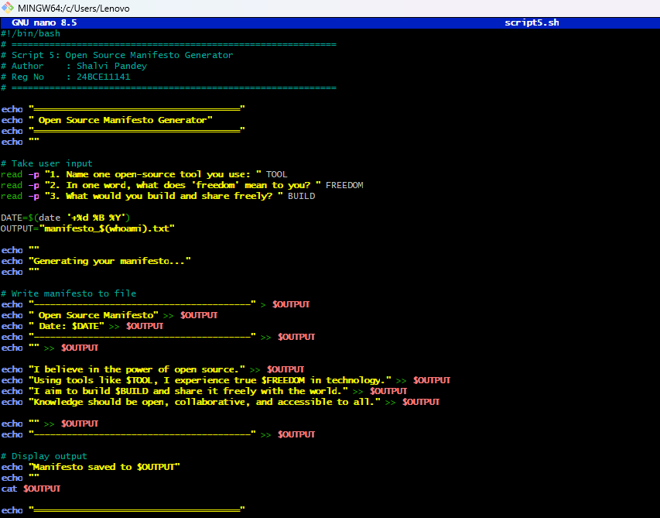
OUTPUT
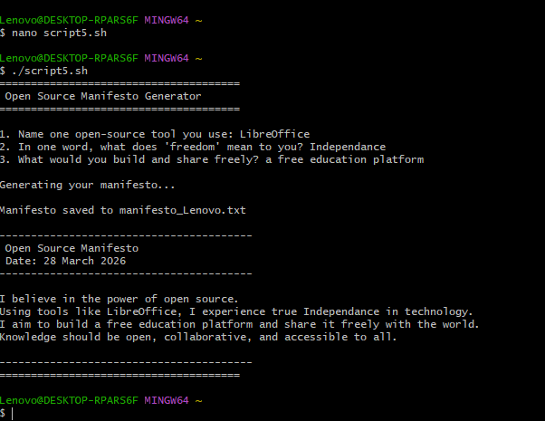

3.7 Conclusion
The five scripts demonstrate basic shell scripting concepts such as variables, loops, conditional statements, and file handling. These scripts provide practical understanding of Linux commands and show how automation can be achieved using simple scripts.

